Data Handling and Visualization (DSA06)
Name: Prasanna M Reg. No: 1925260244
Set 19: Survey Responses Analysis
Question 1. Create a grouped bar chart to visualize the distribution of answers for Question 1. Label the chart elements.
Program (R):
library(ggplot2)
survey <- data.frame(Survey_ID = factor(1:3),
Question1 = c("A","B","C"),
Question2 = c("B","A","A"),
Question3 = c("C","D","B"))
ggplot(survey, aes(x = Question1, fill = Survey_ID)) +
geom_bar(position = "dodge", colour = "black") +
labs(title = "Distribution of Answers for Question 1",
x = "Answer Option", y = "Number of Responses", fill = "Survey ID") +
theme_minimal()
Output:
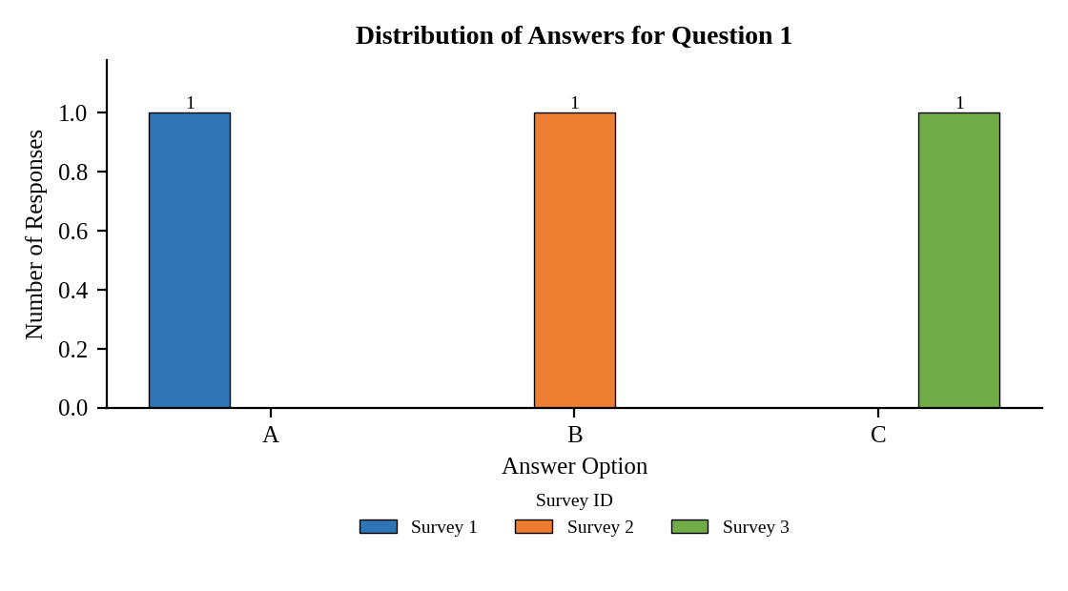
Interpretation:
Question 1 received one response for each of the options A, B and C (from surveys 1, 2 and 3), and none for D. The answers are evenly distributed.

Question 2. Generate a stacked bar chart to represent the overall distribution of responses for all three questions.
Program (R):
library(tidyr)
long <- pivot_longer(survey, cols = starts_with("Question"),
names_to = "Question", values_to = "Answer")
ggplot(long, aes(x = Question, fill = Answer)) +
geom_bar(position = "stack", colour = "black") +
geom_text(stat = "count", aes(label = after_stat(count)), position = position_stack(vjust = 0.5)) +
labs(title = "Distribution of Responses for All Questions",
x = "Question", y = "Number of Responses") +
theme_minimal()
Output:
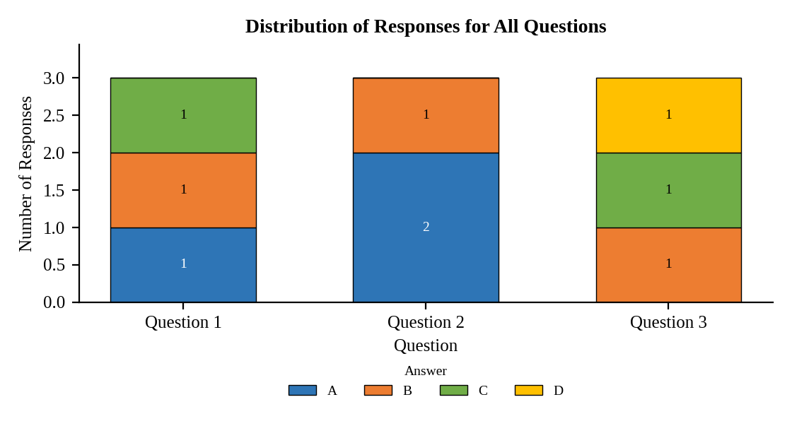
Interpretation:
Answer A is the most common response on Question 2 (2 of 3), B appears on every question, and D occurs only once (Question 3). Question 3 has the widest spread of answers.

Question 3. Build a table to show the survey response data for each survey. Label the table elements.
Program (R):
library(knitr)
kable(survey, align = "c",
col.names = c("Survey ID","Question 1","Question 2","Question 3"),
caption = "Table 19.1: Survey Response Data")
Output:
Table 19.1: Survey Response Data
Survey ID | Question 1 | Question 2 | Question 3
1 | A | B | C
2 | B | A | D
3 | C | A | B

Interpretation:
The table gives the three answers recorded in each survey. No two surveys have the same set of answers.

Question 4. Develop a Tableau dashboard combining the grouped bar chart, stacked bar chart, and the table for interactive exploration of survey responses.
Procedure (Tableau):
1. Open Tableau, click Connect, choose Text file / Microsoft Excel, select "Survey_Responses.csv" and open Sheet 1.
2. Sheet 1 (Grouped bar): Columns = Question 1 and Survey ID (side by side); Rows = COUNT(Survey ID); Color = Survey ID.
3. Pivot Question 1, Question 2 and Question 3 into "Question" and "Answer". Sheet 2 (Stacked bar): Columns = Question; Rows = COUNT(Survey ID); Color = Answer; add labels.
4. Sheet 3 (Table): Rows = Survey ID; Columns = Question; Text = Answer.
5. Click New Dashboard, name it "Survey Responses Dashboard", set Size to Automatic and drag the sheets onto the canvas (charts on top, table below).
6. Select each chart and click the "Use as Filter" icon so that clicking a bar or slice filters the other sheets; keep tooltips enabled.
7. Add a title to every sheet, adjust labels and colours, and save the workbook (File > Save As, .twbx).

Output:
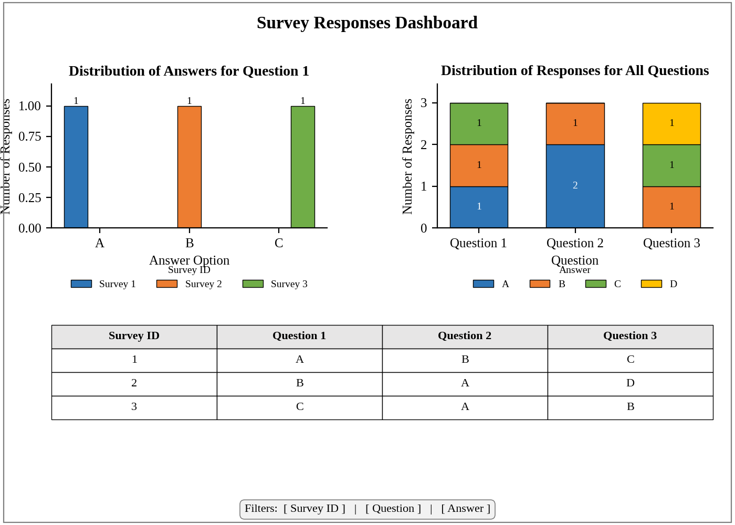
Dashboard layout (preview of the Tableau output).
Interpretation:
Selecting an answer in the stacked bar highlights the surveys that chose it in the table and the grouped bar. The dashboard shows how answers are spread across questions and surveys.

